SOCIAL BALUNI PUBLIC SCHOOL

**CLASS XII**

**BIOLOGY (044)**

**PRETERM EXAMINATION 2020-2021**

**SET B**

**_________________________________________________________________________________**

**Time allowed: 90 Minutes Maximum Marks: 40**

**General Instructions:**

1. The Question Paper contains three sections.
2. Section A has 24 questions. Attempt any 20 questions.
3. Section B has 24 questions. Attempt any 20 questions.
4. Section C has 12 questions. Attempt any 10 questions.
5. All questions carry equal marks.
6. There is no negative marking

**SECTION –A**

**Section – A consists of 24 questions. Attempt any 20 questions from this section. The first attempted 20 questions would be evaluated.**

1. Main reason for development of endosperm before the formation of embryo is
2. There is need form seed from endosperm
3. Development of embryo requires preformed endosperm filled with nutrients.
4. Endosperm is the tissue from which embryo is formed
5. All of above
6. In the figure of mature embryo sac given below, choose the correct option for the characteristic distribution of number of nucleus in cells within the typical embryo sac

|  |  |  |  |  |  |  |  |  |  |  |  |  |  |  |  |  |  |  |  |  |  |
| --- | --- | --- | --- | --- | --- | --- | --- | --- | --- | --- | --- | --- | --- | --- | --- | --- | --- | --- | --- | --- | --- |
|  | |  |  |  |  | | --- | --- | --- | --- | |  | Number of nuclei in antipodal cells | Number of nuclei in synergid cells | Number of nuclei left in central cell | | **a** | 1 | 1 | 2 | | **b** | 3 | 2 | 3 | | **c** | 2 | 3 | 3 | | **d** | 2 | 2 | 4 | |

1. The liquid coconut is
2. cellular endosperm.
3. free nuclear endosperm.
4. both cellular and nuclear endosperm.
5. free nuclear embryo.
6. Among the terms listed below, those that of are not technically correct names for a floral whorl are:
7. Androecium
8. Carpel
9. Corolla
10. Sepal
11. i and iv
12. iii and iv
13. ii and iv
14. i and ii.
15. The outermost and innermost wall layers of microsporangium in an anther are respectively:
16. Endothecium and tapetum
17. Epidermis and endodermis
18. Epidermis and middle layer
19. Epidermis and tapetum
20. Observe figures A and B and choose the correct option from the table below:

|  |  |
| --- | --- |
| Figure A: human female reproductive system | Figure B shows the development of a fertilized human egg cell |
|  |  |

Identify the correct stage of development of human embryo (Figure B) that takes place at the site X, Y and Z respectively in the human female reproductive system (Figure A).  Choose the correct option from the table below;

|  |  |  |  |
| --- | --- | --- | --- |
| Options | X | Y | Z |
| a | Blastocyst | Fertilized egg | Unfertilized egg |
| b | Unfertilized egg | Fertilized egg | Blastocyst |
| c | Morula | Blastocyst | Foetus |
| d | fertilised egg | Blastocyst | Gastrula |

1. Which among the following has 23 chromosomes?
   1. Spermatogonia
   2. Zygote
   3. Secondary oocyte
   4. Oogonia
2. In the wind pollinated plant shown below, identify the characteristics of the male flowers so as to achieve pollination.



|  |  |  |  |
| --- | --- | --- | --- |
| Options | Male inflorescence | Androecium | Characteristic features of pollen |
| a | Tassels | Well exposed in wind | Smooth, light and non-sticky pollens are easily transported in wind current. |
| b | Silk of corn cob | Wave in the wind | Large, feathery and well exposed |
| c | Corn cob | Flowers do not open at all | Long, ribbon like and have mucilaginous covering |
| d | Tips of leaves | Large, colourful, fragrant and rich in nectar | Hard outer layered pollen made up of sporopollenin |

1. The inheritance pattern of colour of flower in snapdragon plants with red flowers crossed another such plant with white flowers is found to be
   * + - 1. Incomplete Dominance
         2. Co-dominance
         3. Pleiotropy
         4. Polygenic inheritance
2. Conditions of a karyotype 2n +1, 2n –1 and 2n + 2, 2n – 2 are called
   * + - 1. Polyploidy
         2. Aneuploidy
         3. Allopolyploidy
         4. Monosomy
3. If a genetic disease is transferred from a phenotypically normal but carrier female to only some of the male progeny, the disease is:
4. Autosomal dominant
5. Autosomal recessive
6. Sex-linked dominant
7. Sex-linked recessive
8. Which of the following hormones is a parthenocarpic fruit?
   * + - 1. Apple
         2. Banana
         3. Strawberry
         4. Cashew
9. Which of the following statements is a correct statement?
10. High levels of estrogen trigger the ovulatory surge.
11. Oogonial cells start to proliferate and give rise to functional ova in regular cycles from puberty onwards.
12. Sperms released from seminiferous tubules are highly motile.
13. Progesterone level is high during the post ovulatory phase of menstrual cycle.The pattern of inheritance of skin colour in human can be termed as:
14. Pleiotropy and codominance
15. Pleiotropy and incomplete dominance
16. Polygenic and qualitative inheritance
17. Polygenic and quantitative inheritance
18. Which of the following combination of sex chromosome represents the correct sex determination pattern in birds?
19. ZW in female bird and ZZ in male bird
20. ZW in male bird and ZZ in female bird
21. XX in female bird and XY in male bird
22. XX in female bird and XO in male bird
23. Which of the following hormones is not secreted by human placenta?
    * + - 1. hCG
          2. Estrogens
          3. Progesterone
          4. LH
24. Rajesh and Mahesh are suffering from Chromosomal Disorders. Rajesh has Trisomy of 21st autosome while Mahesh has Trisomy of sex chromosome. Identify the disorder they are suffering from the following options.

|  |  |  |
| --- | --- | --- |
| Options | Rajesh | Mahesh |
| a | Klinefelter’s syndrome | Turner’s Syndrome |
| b | Klinefelter’s syndrome | Down’s Syndrome |
| c | Down’s Syndrome | Klinefelter’s syndrome |
| d | Turner’s Syndrome | Klinefelter’s syndrome |

1. Location of promoter, structural gene and terminator are described on the basis of
   * + - 1. Template strand
         2. Coding strand
         3. 3’-5’ strand
         4. All of the above
2. Which of the following criteria must a molecule fulfil to act as a genetic material?
   1. It should not be able to generate its replica
   2. It should chemically and structurally be stable
   3. It should not allow slow mutation
   4. It should be able to express itself in the form of Mendelian Characters
   5. (i) and (ii)
   6. (ii) and (iii)
   7. (iii) and (iv)
   8. (ii) and (iv)
3. In E.coli, the lac operon gets switched off when
4. lactose is present and it binds to the repressor.
5. repressor binds to operator.
6. RNA polymerase binds to the operator.
7. lactose is present and it binds to RNA polymerase.
8. In 1928, Frederick Griffith conducted experiments with Streptococcus pneumoniae and concluded that
9. R strain bacteria was transformed by the avirulent S strain bacteria.
10. R strain bacteria was transformed by the DNA of R strain bacteria.
11. R strain bacteria was transformed by the heat-killed S strain bacteria.
12. R strain bacteria was transformed by the proteins of S strain bacteria.
13. Dual functions of AUG are
14. Codes for phenylalanine and act as initiator codon.
15. Codes for methionine and act as initiator codon.
16. Codes for methionine and act as stop codon.
17. Codes for valine and act as start codon.
18. Which of the following is correct about processed and mature RNA in eukaryotes?
    * + - 1. Exons are present
          2. Contains both exons and introns
          3. Introns are present
          4. Methyl guanosine triphosphate is absent in the 5’ end of RNA.
19. Radio labelled probe used in DNA finger printing is
20. Variable Number of Tandem Repeats (VNTR)
21. Untranslated region (UTR)
22. Satellite DNA
23. Micro-satellite DNA

**SECTION –B (2 Marks each)**

**Section - B consists of 24 questions (Sl.No.25 to 48). Attempt any 20 questions from this section. The first attempted 20 questions would be evaluated.**

Question numbers 25 to 28 consist of two statements – Assertion (A) and Reason (R). Answer these questions by selecting the appropriate option given below:

1. Both A and R are true and R is the correct explanation of A
2. Both A and R are true and R is not the correct explanation of A
3. A is true but R is false
4. A is False but R is true
5. **Assertion:** Saheli is a steroidal oral contraceptive for females.

**Reason:** Saheli is a "once a week" oral pill with very few side effects.

1. **Assertion:** Placenta act as endocrine tissue.

**Reason:** Produces several hormones like hCG, hPL, estrogens and progesterone.

1. **Assertion:** Stronger the linkage between two genes lower is the frequency of recombination

**Reason:** Two tightly linked genes did not segregate independently and show low recombination

1. **Assertion:** Condoms, cervical caps and vaults are used as barrier methods

**Reason:** Condoms, cervical caps and vaults cover the cervix during coitus and prevent conception by blocking the entry of sperms through the cervix.

1. Maternal pituitary hormone released during foetal ejection reflex is
2. Follicle stimulating hormone
3. Oxytocin
4. Luteinising hormone
5. Progesterone
6. Which of the following is the type of flower in common pansy which produces assured seed set as it doesn’t open at all is
7. Cleistogamous flower
8. Chasmogamous flower
9. Hypogynous flower
10. Epigynous flower
11. The structure which connects placenta to embryo and is helping in transport of substance to and from embryo is
12. Trophoblast
13. Uterine tissue
14. Chorionic villi
15. Umbilical cord
16. The technique by which the embryo with more than 8 blastomeres could be transferred into the female who is undergoing IVF treatment for blocked fallopian tubes is
17. Zygote Intra Fallopian Transfer (ZIFT)
18. Gamete Intra Fallopian Transfer (GIFT)
19. Intra Cytoplasmic Sperm Injection (ICSI)
20. All of the above
21. In a fertilized ovule, n, 2n and 3n conditions occur respectively in
22. antipodal, zygote and endosperm
23. zygote, nucellus and endosperm
24. endosperm, nucellus and zygote.
25. antipodals, synergids and integuments
26. A monohybrid cross is made between tall pea plants having green pods and dwarf pea plants having yellow pods. In the F2 generation, out of 80 plants how many are likely to be dwarf plants?
27. 5
28. 20
29. 45
30. 10
31. The principle of using Copper releasing IUDs is
32. Increase the movement of sperm.
33. To make the uterus unsuitable for implantation and the cervix hostile to the sperms.
34. To suppress sperm motility and the fertilising capacity of sperms. Chasmogamous flower
35. To inhibit ovulation and implantation.
36. The special mechanism of producing seeds without fertilisation is
37. Apomixes
38. Polyembryony
39. Parthenocarpy
40. Both a and b
41. A student had conducted an artificial cross between a pea plant bearing a violet coloured flower and another pea plant with white flower with known genotype of ww. The student observed that half of the plants bearing white flower and remaining half of the plants bearing violet flowers. What would be the genotype of dominant phenotypic plant?
42. Homozygous dominant (WW)
43. Homozygous recessive (ww)
44. Heterozygous dominant (Ww)
45. Both a and b
46. What would be the genotype of the parents if the offspring have the phenotypes in 1:1 proportion?
47. Aa X Aa
48. AA X AA
49. Aa X AA
50. Aa x aa
51. Observe the pedigree chart and answer the following question.

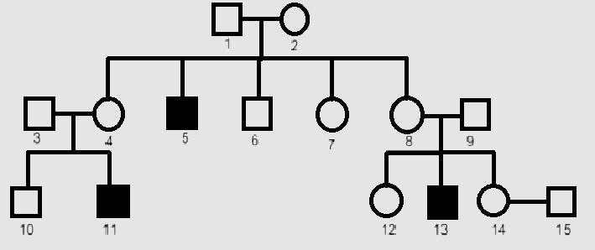

What is the pattern of inheritance in the above pedigree chart?

1. Autosomal dominant
2. Autosomal recessive
3. Sex-linked dominant
4. Sex-linked recessive
5. Genotypic ratio of 1 : 2 : 1 is obtained in a cross between
6. TT x tt
7. Tt x tt
8. TT x Tt
9. tt x tt
10. Which of the following is the basis on which double helix model of DNA was proposed by James Watson and Francis Crick?
11. Crystallised DNA X-ray diffraction data
12. Complementary base pairing and Chargaff rule
13. Complementary pairing of antiparallel strands of DNA.
14. All of the above
15. A couple has two daughters. What is the probability that the third child will also be a female?
16. 25%
17. 50%
18. 75%
19. 100%
20. Number of nitrogenous base pairs in a mammalian cell is 6.6 × 109 bp. What is the length of the DNA in meters?
21. 22 metres
22. 20 metres
23. 200 metres
24. 2.2 metres
25. Observe molecular structure given below. Which of the following statement is correct?

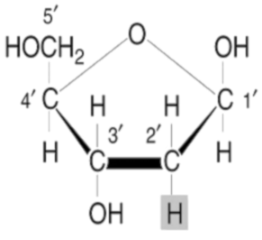

1. 2'-H group of the molecule makes it more reactive and structurally less stable.
2. 2'-H group of the molecule makes it less reactive and structurally stable.
3. Given molecular structure is ribose sugar.
4. Given molecular structure is a structural composition of RNA.
5. Adding of Methyl guanosine triphosphate to the 5'-end of hnRNA during the processing of transcribed RNA in eukaryotes is known as
6. Capping
7. Splicing
8. Tailing
9. Aminoacylation
10. A method of HGP in which sequencing the whole set of genome that contained all the coding and non-coding sequence and later assigning different regions in the sequence with functions is
11. Expressed Sequence Tags (ESTs)
12. Sequence Annotation
13. Automated DNA sequencing
14. All of above
15. If Meselson and Stahl's experiment is continued for sixth generations in bacteria, the ratio of Heavy strands 15N/15N :Hybrid15N/14N : light 14N/14N containing DNA in the sixth generation would be
16. 1:1:1
17. 0:1:7
18. 0:1:15
19. 0:1:31
20. Which of the following statement is false regarding DNA fingerprinting?
21. Used to compare the DNA sequences of any two individuals or among individuals of a population.
22. Uses repetitive DNA as probe.
23. Doesn’t involve hybridisation using radio labelled VNTR probe and autoradiography
24. Involve Hybridisation using radio labelled VNTR probe

**SECTION–C**

**Section-C consists of one case followed by 6 questions linked to this case (Q.No.49 to 54). Besides this, 6 more questions are given. Attempt any 10 questions in this section. The first attempted 10 questions would be evaluated.**

**Case:** Study the following graph showing superimposed curves of different levels of production of FSH and LH during menstrual cycle.



1. Which of the following condition induces rupturing of Graafian follicle and triggers ovulation?
2. LH surge
3. FSH surge
4. Estrogen surge
5. Progesterone surge
6. Which of the following pituitary hormone is produced in higher quantity on the fourteenth day of menstrual cycle?
7. Estrogen
8. Progesterone
9. Luteinising hormone
10. Follicle stimulating hormone
11. Secretion of estrogen and progesterone is triggered by
12. Estrogen
13. Progesterone
14. Luteinising hormone
15. Follicle stimulating hormone
16. Which of the following pituitary hormone stimulate follicular development?
17. Estrogen
18. Progesterone
19. Luteinising hormone
20. Follicle stimulating hormone
21. Transformation of ruptured Graafian follicle into corpus luteum occurs during
22. Ovulatory phase
23. Luteal phase
24. Proliferative phase
25. Menstrual phase
26. Which of the following statements is true about corpus luteum?
27. Corpus luteum is immature Graafian follicle.
28. Corpus luteum secrete large amounts of progesterone.
29. Corpus luteum never degenerate in human females.
30. Presence of corpus luteum marks the beginning of menstrual cycle
31. Three children A, B and C were found to have blood group genes *IAIB, IAi,* and ii. Their blood groups are
32. AB, A, and O respectively
33. B, A and O respectively
34. A, A and O respectively
35. A, B and O respectively
36. T.H Morgan and his colleagues had conducted dihybrid cross with sex-linked genes. Which of the following observation and result drawn by them is incorrect?
37. Two genes in their experiment did not segregate independently.
38. F2 ratio of their experiment was found 9:3:3:1.
39. Observed that very tightly linked genes on chromosome showed very low recombination
40. Observed that two loosely linked genes on chromosome showed higher recombination.
41. Placed below is a karyotype of a human being.

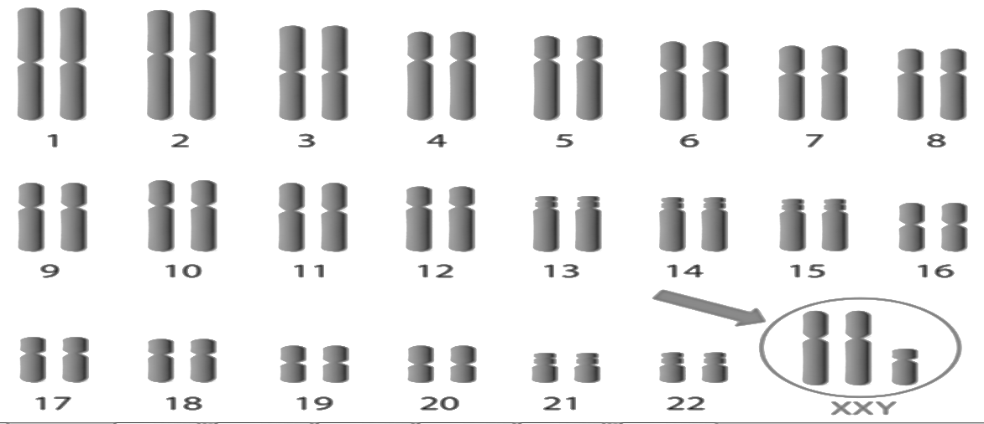

On the basis of this karyotype, which of the following conclusions can be drawn:

1. Normal human female
2. Affected individual is a female with Down’s syndrome
3. Affected individual is a male with Klinefelter’s syndrome
4. Affected individual is a female with Turner’s syndrome
5. Which of the following functional group must be free at 3' of deoxyribose sugar to synthesise dinucleotide in polymerisation of DNA?
6. Methyl group
7. Hydroxyl
8. Phosphate group
9. Carboxylic acid
10. The main reason for the presence of both a leading and a lagging strand during DNA replication is,
11. DNA polymerase can read only in the direction of 3' to 5'
12. DNA polymerase can only synthesize one strand at a time
13. Only one strand is available to be read at any given time
14. There are not enough RNA primers to have both strands be synthesized simultaneously
15. Translation of mRNA is terminated when
16. Aminoacyl tRNA falls off of the mRNA.
17. the end of the RNA is reached.
18. the stop codon in the mRNA recognises release factor.
19. When rho factor binds to terminator region.

**\*\*\*ALL THE BEST\*\*\***